4ITRC2 Operating System Lab

Lab Assignment 4

**Aim**: To study and learn about various system calls

**To perform:** Comprehensive study of different categories of Linux system calls, categorized as

1. Process Management System calls

fork()🡪 Creates a new process (child) by duplicating the calling process (parent).

Example :

#include <stdio.h>

#include <unistd.h>

int main() {

pid_t pid = fork();

if (pid == 0)

printf("Child process: PID = %d\n", getpid());

else

printf("Parent process: PID = %d, Child PID = %d\n", getpid(), pid);

return 0;

}

exec()🡪Replaces the current process image with a new one.

Example :

#include <unistd.h>

int main() {

execl("/bin/ls", "ls", "-l", NULL);

return 0;

}

wait()🡪Makes the parent wait for child process to finish.

Example :

#include <stdio.h>

#include <sys/wait.h>

#include <unistd.h>

int main() {

if (fork() == 0)

execl("/bin/sleep", "sleep", "2", NULL);

else {

wait(NULL);

printf("Child completed.\n");

}

return 0;

}

exit()🡪Terminates the calling process.

Example :

#include <stdlib.h>

int main() {

exit(0);

}

1. File Management System calls

These are used to perform operations on files (open, read, write, close).

open() 🡪 Opens a file and returns a file descriptor.

Example:

#include <fcntl.h>

#include <unistd.h>

int fd = open("file.txt", O_RDONLY);

read() 🡪 Reads data from a file descriptor.

Example:

char buffer[100];

read(fd, buffer, sizeof(buffer));

write() 🡪 Writes data to a file descriptor.

Example:

write(fd, "Hello", 5);

close() 🡪 Closes an opened file descriptor.

Example: close(fd);

1. Device Management System calls

These are used to manage hardware devices via file descriptors

read()/write()

ioctl()🡪 Device-specific input/output control.

select()🡪 Monitors file descriptors.

1. Network Management System calls socket()🡪Creates a socket

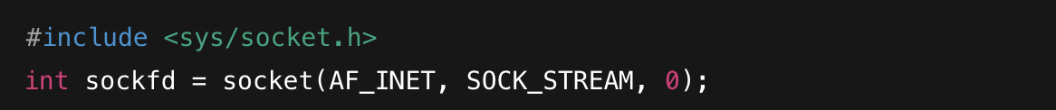

connect(),send(),recv()🡪

**Example (Client-side socket):** 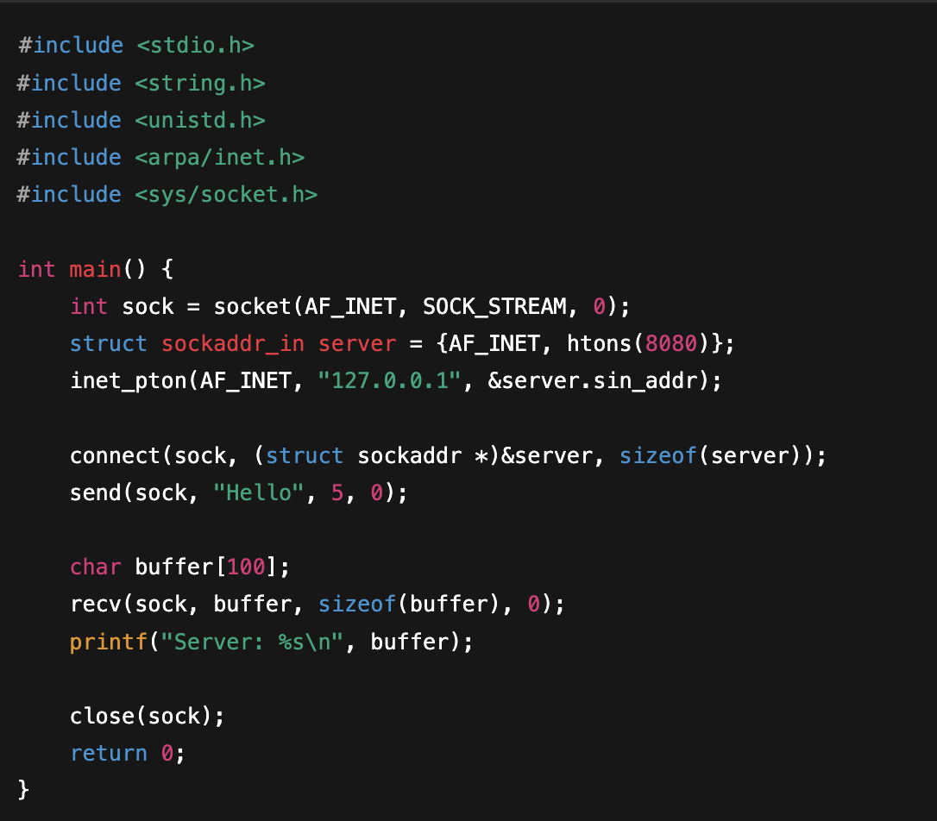

1. System Information Management System calls

getpid()🡪

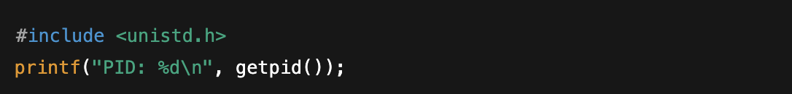

getuid()🡪



gethostname()🡪

sysinfo()🡪

